

UNIVERSITY OF HERTFORDSHIRE
School of Physics, Engineering and Computer Science
MSc Artificial Intelligence and Robotics
7COM1039-0206-2025 – Advanced Computer Science Masters Project
Final Project Report
27th April 2026
A Comparative Study of Pretrained CNN Architectures and Fine-Tuning Strategies for Astronomical Image Classification with Limited Data

Name: Mohammad Umer Khan
Student ID: 24054795
Supervisor: Kheng Lee Koay
Proof-Read and Quality Check Declaration:
I confirm that this report has been critically proof-read and quality checked, ensuring it is free from grammar, spelling, and formatting errors, and meets a high standard of clarity, coherence, and presentation.

MSc Final Project Declaration
This report is submitted in partial fulfilment of the requirements for the degree of:
Master of Science in Artificial Intelligence and Robotics, at the University of Hertfordshire (UH).
I hereby declare that the work presented in this project and report is entirely my own, except where explicitly stated otherwise. All sources of information and ideas, whether quoted directly or paraphrased, have been properly referenced in accordance with academic standards. I understand that any failure to properly acknowledge the work of others may constitute plagiarism and could result in academic penalties.
I did not use human participants in my MSc Project.
I hereby give permission for this report to be made available on the university website, provided the source is acknowledged.

Name: Mohammad Umer Khan
Student ID: 24054795
Date: 27th April 2026

Table of Contents
1. Abstract 1
2.Introduction 2
2.1 Problem Overview 2
2.2 Current Issues 2
2.3 Project Details 3
2.4 Aims and Objectives 4
2.5 Research Question and Novelty 4
2.6 Feasibility, Commercial Context, and Risk 5
2.7 Report Structure 5
3. Literature Review 6
3.1 Introduction to the Field 6
3.2 Key Studies and Work 8
3.3 Depth and Breadth of Coverage 9
3.4 Comparative Analysis 12
3.4 Identification of Gaps 14
4. Methodology 16
4.1 Choice of Methods 16
4.2 Justification and Support of Choices 18
4.3 Project Design and Data Collection 20
4.4 Use of Tools and Techniques 21
4.5 Test Strategy 23
4.6 Testing and Results 24
4.7 Validation 27
4.8 Ethical, Legal, Social and Professional Issues 28
4.9 Practicality 29
5. Quality And Result 30
5.1 Metrics and Presentation 30
5.2 Critical Analysis 32
5.3 Evidence of Practical Work 35
5.4 Technical Challenges and Solutions 38
5.5 Novelty and Innovation 40
5.6 Interpretation of Results 42
5.7 Tools, Objectives, and Feasibility 43
6. Evaluation and Conclusions 45
6.1 Final Evaluation 45
6.2 Project Management 46
6.3 Insights Gained 47
6.4 Comparison to Literature 49
6.5 Reflection on Challenges 51
6.6 Future Work 52
6.7 Conclusion 53
7. References 54
8. Appendices 57
8.1 Appendix A: Dataset Analysis 57
8.2 Appendix B: Custom CNN Results 58
8.3 Appendix C: EfficientNetV2B0 Results 59
8.4 Appendix D: ResNet50 Results 60
8.5 Appendix E: Model Comparison 61

Figure 1 Dataset Class Distribution Graph 61
Figure 1 Dataset Class Distribution Graph 61
Figure 2 Sample Images from Dataset 61
Figure 2 Sample Images from Dataset 61
Figure 3 Custom CNN Accuracy Curve 62
Figure 3 Custom CNN Accuracy Curve 62
Figure 4 Custom CNN Loss Curve 62
Figure 4 Custom CNN Loss Curve 62
Figure 5 EfficientNetV2B0 Validation Accuracy Graph 63
Figure 5 EfficientNetV2B0 Validation Accuracy Graph 63
Figure 6 EfficientNetV2B0 Validation Loss Graph 63
Figure 6 EfficientNetV2B0 Validation Loss Graph 63
Figure 7 ResNet50 Validation Accuracy Graph 64
Figure 7 ResNet50 Validation Accuracy Graph 64
Figure 8 ResNet50 Validation Loss Graph 64
Figure 8 ResNet50 Validation Loss Graph 64
Figure 9 ResNet50 Confusion Matrix 64
Figure 9 ResNet50 Confusion Matrix 64
Figure 10 Bar chart Model Comparison (Validation Accuracy) 65
Figure 10 Bar chart Model Comparison (Validation Accuracy) 65
Figure 11 Fine Tuning Improvement Graph 65

1. Abstract
This project investigates the performance of convolutional neural network (CNN) architectures and transfer learning strategies for astronomical image classification under limited data conditions. The objective was to compare a custom CNN trained from scratch with pretrained models, specifically ResNet50 and EfficientNetV2B0, using feature extraction and fine-tuning approaches. A structured experimental pipeline was implemented using TensorFlow and Keras, including consistent data preprocessing, training, and evaluation. The dataset consisted of approximately 12,900 images across eight classes, with class imbalance and visual similarity presenting key challenges, partially mitigated through data augmentation and class weighting. Model performance was evaluated using validation accuracy, loss curves, and confusion matrix analysis. The results show that transfer learning improves performance compared to training from scratch, with pretrained models outperforming the custom CNN. ResNet50 achieved the highest accuracy, particularly with fine-tuning, while EfficientNetV2B0 showed smaller gains, indicating limited benefit in smaller, domain-specific datasets. The results show that architecture, training strategy, and dataset characteristics all affect performance, with class imbalance and feature similarity continuing to be important constraints. Overall, the study demonstrates that transfer learning is an effective and practical approach for astronomical image classification in data-constrained environments, with future work focusing on improving dataset balance, refining training strategies, and expanding model evaluation.

2.Introduction

2.1 Problem Overview
With the progression of humanity’s exploration of space, there has been a drastic growth with observational data generated by these advancements. Deep learning techniques, particularly convolutional neural networks (CNNs), have demonstrated strong performance in visual recognition tasks, which has allowed automated analysis of large-scale datasets. CNN-based approaches have been successfully applied to tasks such as galaxy classification, significantly improving efficiency compared to manual analysis (Gharat and Dandawate, 2022).

2.2 Current Issues
One of the main challenges in astronomical image classification is the limited availability of labelled data for certain object classes, which restricts model performance. Convolutional neural networks (CNNs) typically require large datasets to generalise effectively, and when trained from scratch on limited data, they are prone to overfitting. Transfer learning has emerged as a key solution, enabling models pretrained on large-scale datasets such as ImageNet to be adapted to domain-specific tasks, reducing data requirements and improving performance (Jahed and Sarvari, 2024).
However, uncertainty remains regarding the most effective architecture and training strategies for such constrained settings. Models such as ResNet50 and EfficientNetV2B0 represent different design approaches, with residual connections enabling deeper learning in ResNet (He et al., 2016) and compound scaling improving efficiency in EfficientNet (Tan and Le, 2019; Tan and Le, 2021). While EfficientNet models often achieve strong results on large-scale benchmarks, their performance in specialised domains such as astronomical image classification is less consistent.

2.3 Project Details
This project aims to conduct a comparative study of pretrained CNN architectures, specifically ResNet50 and EfficientNetV2B0, for the classification of astronomical images under limited data conditions. The models are evaluated using both feature extraction and fine-tuning strategies, allowing a direct comparison of their effectiveness under different transfer learning approaches. A custom CNN model trained from scratch is also implemented as a baseline to assess the benefits of transfer learning.

2.4 Aims and Objectives
The primary objectives of this project are:
- To evaluate the effectiveness of transfer learning for astronomical image classification using limited data
- To compare the performance of ResNet50 and EfficientNetV2B0 architectures
- To analyse the impact of feature extraction and fine-tuning on classification accuracy
- To assess model performance using validation accuracy, loss curves, and confusion matrices
- To investigate the effects of class imbalance and the use of class weighting techniques

2.5 Research Question and Novelty
The central research question addressed in this study is:
"How do pretrained CNN architectures (ResNet50 and EfficientNetV2B0) and transfer learning strategies (feature extraction vs fine-tuning) impact the performance of astronomical image classification under limited data conditions?"
This research contributes to the field by providing a practical evaluation of modern and traditional CNN architectures within a constrained data environment. These findings can be very useful in all fields in the real world that deal with limited labelled data.

2.6 Feasibility, Commercial Context, and Risk
From a feasibility perspective, the project is constrained by dataset size, class imbalance, and computational resources. While techniques such as data augmentation and class weighting are applied to mitigate these challenges, limitations remain and may influence model bias. These aspects are further analysed through evaluation metrics such as confusion matrices in the results section.

2.7 Report Structure
The remainder of this report is structured as follows: Section 3 reviews relevant literature on deep learning and transfer learning for image classification. Section 4 outlines the methodology, including dataset preparation, model design, and training strategies. Section 5 presents experimental results and analysis. Section 6 provides a critical evaluation of the findings and discusses future work. Finally, Section 7 concludes the report.

3. Literature Review

3.1 Introduction to the Field
Deep learning has become the most prevalent approach in image classification, with convolutional neural networks (CNNs) demonstrating cutting edge performance across a wide range of applications. CNNs are specifically designed to learn hierarchical feature representations from image data, making them highly effective for visual recognition tasks such as object detection, segmentation, and classification. Since the introduction of deep CNN architecture such as AlexNet, the field has rapidly evolved, leading to the development of more advanced models capable of achieving higher accuracy and efficiency.
In scientific domains, including astronomy, CNN-based approaches have been increasingly adopted to automate the analysis of large-scale image datasets. Modern telescopes and observational technologies generate large amounts of data, this in turn makes it very difficult and time-consuming to classify all the data manually. Henceforth, deep learning models are now widely used for tasks such as galaxy classification and astronomical object recognition, significantly improving efficiency and scalability (Gharat and Dandawate, 2022).
Despite these advancements, one of the key challenges in applying deep learning to domain-specific problems is the limited availability of labelled data. Many deep learning models require large datasets to achieve optimal performance, which are not always viable in specialized fields such as astronomy where specific categories of data have been limited in number. This has led to the widespread adoption of transfer learning, where models pretrained on large-scale datasets such as ImageNet are adapted to new tasks with smaller datasets. Transfer learning has been shown to significantly improve performance in such scenarios, particularly when combined with fine-tuning strategies (Jahed and Sarvari, 2024).
This study builds upon these developments by focusing on the application of pretrained CNN architectures to astronomical image classification under limited data conditions. Specifically, it investigates how different architectures and transfer learning strategies impact model performance, aligning with the research objectives outlined in the previous section.

3.2 Key Studies and Work
The development of convolutional neural network (CNN) architectures has significantly advanced image classification performance. Early work such as AlexNet established CNNs as the dominant approach in computer vision, with subsequent architectures focusing on improving depth, efficiency, and training stability.
ResNet is one of the most influential architectures, introducing residual connections to address degradation in deep networks. These connections enable more effective gradient flow, allowing significantly deeper models to be trained while maintaining strong performance (He et al., 2016). As a result, ResNet has been widely adopted for complex image classification tasks.
More recent work has focused on improving efficiency without sacrificing accuracy. EfficientNet introduced compound scaling, which balances network depth, width, and resolution to achieve strong performance with fewer parameters (Tan and Le, 2019). EfficientNetV2 further improves this approach through architectural and training optimisations aimed at faster convergence and improved performance (Tan and Le, 2021).
In parallel, transfer learning has become a key technique for addressing limited labelled data. Pretrained CNNs can be adapted using feature extraction or fine-tuning, significantly improving performance compared to training from scratch. Jahed and Sarvari (2024) demonstrate that transfer learning is particularly effective for astronomical image classification, especially when fine-tuning is applied.
Despite these advances, performance is not consistent across all domains. While EfficientNet models often outperform traditional architectures on large-scale benchmarks, their advantages may not be transferred directly to specialized tasks. Factors such as dataset size, class imbalance, and domain-specific features can significantly influence model performance.
Furthermore, most comparative studies focus on large-scale datasets such as ImageNet, with limited evaluation of modern architectures in domain-specific contexts like astronomical image classification. There is also a lack of direct comparison between transfer learning strategies, particularly feature extraction and fine-tuning, under constrained data conditions. This highlights the need for a systematic evaluation of both architecture and training strategy within this domain.

3.3 Depth and Breadth of Coverage
The current landscape of image classification research demonstrates a wide range of approaches, from basic CNN architectures trained from scratch to sophisticated transfer learning-based pretrained models. Earlier approaches focused on designing custom CNN architectures tailored to specific tasks, which could achieve strong performance when large, labelled datasets were available. However, such approaches are often limited in scenarios and areas where data is scarce, as they are prone to generalization and overfitting.
To address these limitations, transfer learning has emerged as a widely adopted technique across multiple domains. Pretrained models can effectively adapt to new tasks with limited data by utilizing knowledge learned from large datasets like ImageNet. Studies have shown that transfer learning significantly improves performance in image classification tasks, particularly when domain-specific data is limited (Jahed and Sarvari, 2024). As a result, it is now widely used in astronomy, remote sensing, and medical imaging.
In addition to transfer learning, recent research has explored different strategies for adapting pretrained models, primarily feature extraction and fine-tuning. Feature extraction involves freezing the pretrained layers and using them as a fixed representation, while fine-tuning allows selective retraining of deeper layers to better capture domain-specific features. These approaches present different trade-offs, with feature extraction offering lower computational cost and reduced risk of overfitting, while fine-tuning generally provides higher performance when sufficient data is available (Davila et al., 2024).
From an architectural perspective, there is a broad range of CNN models available, each with different structures and designs. Traditional architectures such as ResNet focus on enabling deeper networks through residual learning, while more recent models such as EfficientNet prioritize computational efficiency through optimized scaling techniques (He et al., 2016; Tan and Le, 2019). EfficientNetV2 further extends this by incorporating training optimizations aimed at improving both speed and accuracy (Tan and Le, 2021). The variety of options for image classification tasks that are available is made clear by this diversity of architecture.
Even though these methods are available, their effectiveness can vary greatly depending on the domain they are being applied in. In domains such as astronomy, factors including class imbalance, limited labelled data, and the visual similarity between classes can affect model performance. As a result, methods that perform well on benchmark datasets may not necessarily achieve the same level of success in specialized contexts. This demonstrates how crucial it is to assess the suitability of various approaches for domain-specific issues.
Overall, the literature demonstrates depth, through detailed studies of specific architectures such as ResNet and EfficientNet, and through nuanced analyses of training strategies like feature extraction and fine-tuning. It also demonstrates breadth, by examining these methods across diverse domains which include astronomy, remote sensing, and medical imaging—and by considering a range of approaches from CNNs trained from scratch to transfer learning-based models. The variation in performance across domains highlights the importance of context-specific evaluation, emphasizing that methods successful on benchmark datasets may require adaptation for specialized tasks.

3.4 Comparative Analysis
Numerous studies have compared convolutional neural network architectures and training strategies for image classification, with performance varying depending on dataset characteristics and experimental conditions. Custom CNNs trained from scratch offer flexibility but typically require large, labelled datasets, often leading to overfitting and poor generalization in data-constrained environments.
Pretrained architecture such as ResNet and EfficientNet have demonstrated superior performance across many benchmarks. ResNet utilizes residual connections to enable deeper networks and effective feature learning (He et al., 2016), although increased depth introduces higher computational complexity. EfficientNet addresses efficiency through compound scaling, balancing network depth, width, and resolution to achieve strong performance with fewer parameters (Tan and Le, 2019). EfficientNetV2 further improves training efficiency and convergence (Tan and Le, 2021). However, recent studies suggest that these advantages are not always consistent in domain-specific tasks with limited data.
From a training perspective, transfer learning consistently outperforms training from scratch in such scenarios, improving accuracy and robustness (Kartik et al., 2023). Feature extraction offers a stable and computationally efficient approach but may not capture domain-specific features effectively. In contrast, fine-tuning enables better adaptation to the target domain, often improving performance at the cost of increased computational complexity and overfitting risk (Davila et al., 2024).
Comparative studies indicate that while EfficientNet often achieves state-of-the-art results on large-scale datasets, its advantages over established models such as ResNet are not guaranteed in specialized domains. Factors such as dataset size, class imbalance, and feature similarity can significantly influence performance, with simpler or well-established architectures sometimes performing comparably or better when combined with appropriate training strategies.
Despite extensive research on individual architecture and transfer learning techniques, there is limited comparative analysis of how different pretrained models interact with transfer learning strategies under constrained, domain-specific conditions. ResNet50 and EfficientNetV2B0 have not been thoroughly evaluated in astronomical image classification using both feature extraction and fine-tuning approaches.
This study addresses this gap by providing a structured comparison of these architectures and training strategies under limited data conditions, with the aim of identifying the most effective combinations for reliable astronomical image classification.

3.4 Identification of Gaps
Despite the significant progress made in convolutional neural network architectures and transfer learning techniques, there are still a few limitations to the current body of research. Many studies have already shown how architectures like ResNet and EfficientNet on pretrained models are effective on large scale benchmark datasets. There is limited evidence regarding their comparative performance in domain-specific applications, particularly in the field of astronomical image classification.
Existing research has primarily focused on evaluating individual architectures or applying transfer learning techniques in isolation. As a result, there is a lack of comprehensive studies that systematically compare multiple pretrained architectures under the same experimental conditions. This restriction makes it challenging to choose the best model for a given task, particularly when working with limited datasets.
Furthermore, although transfer learning has been widely adopted, there is insufficient analysis of how different transfer learning strategies, such as feature extraction and fine-tuning, interact with various architectures in domain-specific contexts. Factors like dataset size, class imbalance, and feature complexity may affect how effective these strategies are; however, the literature has not thoroughly examined these interactions.
In addition, astronomical image datasets present unique challenges, including limited labelled data, class imbalance, and high visual similarity between classes. There is a knowledge gap about how contemporary architectures function in such circumstances because these features are not sufficiently represented in general-purpose benchmark datasets.
Thus, in the context of astronomical image classification with limited data, a systematic and comparative assessment of pretrained CNN architectures and transfer learning techniques is clearly needed. This study addresses these gaps by systematically comparing ResNet50 and EfficientNetV2B0 using both feature extraction and fine-tuning approaches, giving information about how well they work and whether they are appropriate for domain-specific applications.

4. Methodology

4.1 Choice of Methods
This project adopts a data-driven deep learning approach to address the problem of astronomical image classification under limited data conditions. Convolutional Neural Networks (CNNs) were selected as the primary methodology due to their proven effectiveness in extracting hierarchical features from image data and their widespread use in image classification tasks.
A comparative experimental framework was used to investigate the research question. This involved evaluating multiple model architectures and training strategies under consistent conditions. Specifically, three approaches were considered: a custom CNN trained from scratch, and two pretrained architectures (ResNet50 and EfficientNetV2B0) applied using transfer learning techniques. This design allows for a structured comparison between traditional deep learning approaches and modern transfer learning-based methods.
Transfer learning was selected as a core method due to its suitability for scenarios with limited labelled data. Pretrained networks that were first trained on large-scale datasets like ImageNet were modified for the target task instead of creating models from scratch. By utilizing previously learned feature representations, this method improves generalization performance and eliminates the need for sizable domain-specific datasets.
Feature extraction and fine-tuning were the two transfer learning techniques used. Feature extraction involves freezing the pretrained convolutional base and training only the classification layers, providing a computationally efficient and stable baseline. Fine-tuning extends this approach by unfreezing a portion of the deeper layers, allowing the model to adapt to domain-specific features. Because both approaches are included, it is possible to compare their efficacy directly in the context of classifying astronomical images.
The choice of ResNet50 and EfficientNetV2B0 was motivated by their differing architectural characteristics and their relevance in existing literature. ResNet50 is a popular deep architecture that effectively trains deeper networks by leveraging residual connections, while EfficientNetV2B0 represents a more recent architecture that focuses on optimized scaling and computational efficiency. It is possible to ascertain whether modern architecture consistently performs better than more conventional ones in domain-specific scenarios by comparing these models.
The TensorFlow and Keras frameworks, which offered effective tools for deep learning model development, training, and evaluation, were used to implement all models. Overall, the chosen techniques are in line with the project's research goals, allowing for a methodical examination of the effects of various CNN architectures and transfer learning techniques on classification performance in situations with limited data.

4.2 Justification and Support of Choices
The selection of methods and model architectures was guided by dataset characteristics and existing research in image classification. Convolutional Neural Networks (CNNs) were chosen due to their effectiveness in learning spatial feature hierarchies from image data. Although transformer-based models have gained popularity, they typically require larger datasets and greater computational resources, making CNNs more suitable for this project’s constrained setting.
Given the limited availability of labelled astronomical data, transfer learning was adopted as the primary strategy. Under such circumstances, training CNNs from scratch frequently results in overfitting and poor generalization. Transfer learning enables pretrained models, such as those trained on ImageNet, to be adapted to new tasks with reduced data requirements and has been shown to improve performance in small dataset scenarios (Kartik et al., 2023). A custom CNN was included as a baseline to enable direct comparison with pretrained approaches.
ResNet50 was selected for its strong performance and use of residual connections, which allow deeper networks to be trained effectively without degradation (He et al., 2016). It provides a balance between representational capacity and computational cost compared to smaller and deeper variants. EfficientNetV2B0 was chosen as a representative of more recent architectures, incorporating compound scaling and training optimisations to improve efficiency and accuracy (Tan and Le, 2021). The B0 variant is suitable for this study because it provides a good trade-off between performance and computational requirements.
Both feature extraction and fine-tuning strategies were evaluated. Feature extraction reduces overfitting by freezing pretrained layers, while fine-tuning allows adaptation to domain-specific features at the cost of increased computational complexity (Davila et al., 2024). Comparing these approaches enables assessment of their relative effectiveness.
Flipping, rotating, and zooming are examples of data augmentation techniques that were used to improve generalization and diversify datasets. Because of their robust support for deep learning and transfer learning workflows, TensorFlow and Keras were utilized. All things considered, these decisions allow for a methodical assessment of how architecture and training approach affect performance in situations with limited data.

4.3 Project Design and Data Collection
The project follows a structured experimental design in which multiple convolutional neural network architectures and training strategies are evaluated under consistent conditions. The system consists of three main stages: data preparation, model training, and evaluation, ensuring fair and systematic performance comparison across models.
The dataset used is SpaceNet: A Comprehensive Astronomical Dataset, generated using a double-stage augmentation framework (FLARE) for astronomical image recognition (Alam et al., 2024). It contains approximately 12,900 images across eight classes: asteroid, black hole, comet, constellation, galaxy, nebula, planet, and star. The dataset was selected due to its fine-grained class structure and representation of challenges such as class imbalance and visual similarity.
Data is organised in a directory-based structure, enabling efficient loading using TensorFlow utilities. The dataset was split into training and validation subsets using an 80:20 ratio to ensure evaluation on unseen data.
Exploratory data analysis (EDA) was conducted to examine class distribution and sample images, revealing significant class imbalance, with classes such as galaxies and stars having more samples than others. To mitigate this, class weighting was applied during training.
All images were resized to 224×224 pixels to match pretrained model input requirements. TensorFlow’s data pipeline, including batching, caching, and prefetching, was used to optimise training performance.
No primary data collection involving human participants was conducted. The dataset is publicly available and contains no personal or sensitive information, ensuring compliance with ethical and legal standards.
Overall, the structured dataset and experimental design provide a reliable foundation for evaluating CNN architectures and transfer learning strategies.

4.4 Use of Tools and Techniques
A range of software tools and frameworks were used to support model implementation, training, and evaluation. These were selected based on their suitability for deep learning workflows and compatibility with transfer learning techniques.
The project was implemented in Python, using TensorFlow and its high-level API Keras as the primary deep learning frameworks. These were chosen for their strong support for convolutional neural networks and seamless integration of pretrained models such as ResNet50 and EfficientNetV2B0. Compared to PyTorch, TensorFlow was preferred due to its streamlined support for pretrained architectures and ease of experimentation with transfer learning.
TensorFlow’s dataset API was used for efficient data handling and preprocessing, including batching, caching, and prefetching to optimise training performance. Data augmentation techniques, such as flipping, rotation, and zooming, were applied using Keras preprocessing layers to improve generalisation.
NumPy supported numerical operations, while Matplotlib was used to visualise training and validation performance through accuracy and loss curves, as well as model comparison graphs. Scikit-learn was used to generate confusion matrices, enabling detailed class-wise performance analysis.
The development environment was based on a local machine using Visual Studio Code. While this provided flexibility and control, it introduced computational limitations, influencing decisions such as selecting EfficientNetV2B0 over larger variants and limiting training epochs.
OVerall, these tools offered a useful framework for putting models into practice and assessing them, supporting the project's experimental design and goals within realistic limitations.

4.5 Test Strategy
The testing strategy was designed to systematically evaluate convolutional neural network architectures and transfer learning approaches under consistent experimental conditions. As the project focuses on machine learning, testing was centred on performance evaluation, model comparison, and validation using unseen data.
All experiments used the same dataset split, preprocessing procedures, and training conditions to ensure fair comparison. The dataset was divided into training and validation sets using an 80:20 ratio, allowing models to be evaluated on unseen data and providing an unbiased measure of generalisation.
Model performance was assessed using classification accuracy and loss. Accuracy measured overall prediction correctness, while loss reflected model fit during training and validation. Monitoring both metrics enabled identification of overfitting, underfitting, and training instability. Confusion matrices were also used to analyse class-wise performance, highlighting misclassification patterns and the impact of class imbalance.
With a few small tweaks for fine-tuning, all models were trained using the same batch size, epochs, and optimization parameters. This controlled setup made sure that variations in performance could be attributed to training strategy and architecture.
A custom CNN trained from scratch and pretrained models using both feature extraction and fine-tuning were included in the comparative evaluation. To guarantee stability and dependability, validation performance was continuously observed. The structured approach offers a dependable and comparable evaluation that is in line with the project objectives, even though cross-validation was not used because of limitations.

4.6 Testing and Results
The testing process involved training and evaluating multiple convolutional neural network models under controlled and consistent experimental conditions. All models were trained using the same dataset split, preprocessing pipeline, and hyperparameter settings where applicable, ensuring that comparisons between models were fair and reliable.
The primary models evaluated included a custom CNN trained from scratch, as well as pretrained ResNet50 and EfficientNetV2B0 models using both feature extraction and fine-tuning strategies. Training and validation accuracy and loss metrics were used to track performance over several training epochs. Throughout the training process, these metrics offered ongoing feedback on the model's learning behaviour and convergence.
The custom CNN model demonstrated gradual learning, with training and validation accuracy increasing over time and reaching approximately 44–45%. The loss curves showed a rapid initial decrease followed by stabilization, although validation performance exhibited fluctuations, indicating some instability and limited generalization capability.
The pretrained models showed significantly improved performance compared to the custom CNN. EfficientNetV2B0 achieved validation accuracy of approximately 54% using feature extraction, with fine-tuning providing a slight improvement in performance. The validation loss decreased steadily, indicating stable convergence during training.
ResNet50 produced significantly better performance, achieving approximately 70% validation accuracy with feature extraction and 79% with fine-tuning. This suggests that deeper residual architectures are better able to capture hierarchical features in astronomical imagery compared to both shallow CNNs and EfficientNetV2B0 under the given dataset constraints. The loss curves for ResNet50 showed consistent reduction over training epochs, particularly for the fine-tuned model, demonstrating effective learning and strong convergence.
Confusion matrices were created to analyse class-wise predictions to further assess model performance. These provided detailed insight into how each model performed across different classes and highlighted patterns of misclassification. The results indicated a strong bias towards majority classes, particularly the “star” class, reflecting the impact of class imbalance within the dataset. This indicates that dataset imbalance had a measurable impact on predictive bias, with minority classes such as asteroids and comets being more frequently misclassified.
Transfer learning techniques greatly outperformed the custom CNN model, according to a comparative study of model performance. Fine-tuning generally provided additional improvements over feature extraction, although the magnitude of improvement varied between architectures. ResNet50 with fine-tuning achieved the best performance overall, indicating that deeper architecture combined with domain-specific adaptation are highly effective for this task.
The effectiveness of the models was assessed using validation accuracy as the primary benchmark, supported by loss metrics and confusion matrix analysis. These evaluation criteria provided a comprehensive measure of model performance, ensuring that both overall accuracy and class-level behaviours were considered.
Overall, the results demonstrate that pretrained CNN architectures significantly outperform models trained from scratch in limited data scenarios, with fine-tuning further improving performance through domain-specific adaptation. ResNet50 achieved the highest overall validation accuracy, confirming its effectiveness for this task and supporting the use of transfer learning for astronomical image classification.

4.7 Validation
The validity and reliability of the results were ensured through a structured validation approach based on unseen data, controlled experimental conditions, and multiple evaluation metrics. Validation was primarily conducted using a dedicated validation dataset and performance monitoring during training.
The dataset was split into training and validation subsets using an 80:20 ratio. The validation set was not used during training, ensuring that performance metrics reflected the model’s ability to generalise to unseen data and reducing the risk of overfitting.
All models were trained and evaluated using consistent preprocessing techniques, dataset splits, and hyperparameter configurations where applicable. This controlled setup ensured that performance differences were attributable to model architecture and training strategy rather than external factors.
Model validation was supported by validation accuracy and loss metrics, which enabled detection of overfitting, underfitting, and training instability. Confusion matrices were also used to assess class-level performance, highlighting the impact of class imbalance and model generalisation across categories.
Cross-validation was not implemented due to computational constraints; however, the use of a sufficiently large validation set and consistent training procedures provided a reliable basis for evaluation. Comparative analysis across custom CNN, feature extraction, and fine-tuned models further supported the robustness of the findings.
There are still restrictions in place despite these steps. The results of the confusion matrix show that limited data and class imbalance still have an impact on generalization performance. The evaluation section goes into more detail about these restrictions.

4.8 Ethical, Legal, Social and Professional Issues
This project does not involve human participants or personal data and therefore does not require ethical approval. The SpaceNet data set used is publicly available and contains only astronomical images, ensuring no privacy concerns.
All data was used in accordance with licensing and academic integrity requirements, with appropriate citation of sources. From a broader perspective, the results highlight the issue of model bias due to class imbalance, where the model shows a tendency to favour majority classes.
This brings up crucial issues with reliability and fairness when using machine learning models in practical settings. Transparency, reproducibility, and accurate reporting of methods and results are ensured by the project's adherence to professional research standards.

4.9 Practicality
Computational and dataset limitations affect the project's viability. The dataset's imbalance has an impact on model performance and leads to biased predictions, especially about majority classes.
The project was implemented on a local machine without high-performance GPU resources, limiting model complexity and training duration. This influenced the selection of EfficientNetV2B0 and controlled training configurations to ensure feasibility.
Despite these constraints, the use of transfer learning enabled effective model performance without requiring large datasets or extensive computational resources.
Although more improvements could be made with larger datasets and more sophisticated hardware, the project shows a workable and feasible method for image classification under constrained data conditions.

5. Quality And Result

5.1 Metrics and Presentation
The performance of the models in this study was evaluated using a combination of quantitative metrics and visual analysis techniques. Validation accuracy, which calculates the percentage of correctly classified images on unseen data, was the main metric employed, as it directly reflects each model’s ability to generalise.
In addition to accuracy, loss values were monitored throughout training to assess model convergence and learning behaviour. Training and validation loss curves were used to identify issues such as overfitting and instability during training. An increase in validation loss indicates overfitting and reduced model generalisation, making it a key indicator of model stability.
Class-wise predictions were analysed using confusion matrices to offer a more thorough assessment of the model's performance. Confusion matrices are useful for assessing fine-grained classification performance because misclassifications were more common between visually similar classes, such as galaxies and nebulae. Because of the dataset's class imbalance, this was especially crucial.
Results were visualised using bar charts for model comparison, learning curves (accuracy and loss) to represent training behaviour, and confusion matrices to evaluate class-level performance. The custom CNN, EfficientNetV2B0, and ResNet50 models under both feature extraction and fine-tuning configurations could be clearly compared thanks to these visualizations.
The use of validation accuracy, loss, and confusion matrices aligns with standard evaluation practices in CNN-based image classification studies (Jahed and Sarvari, 2024), ensuring comparability with existing literature. A thorough evaluation of the model's performance was provided by using validation accuracy as the main benchmark, which was bolstered by loss trends and class-level analysis.
These metrics directly support the project objectives by enabling systematic comparison of CNN architectures and transfer learning strategies under limited data conditions.

5.2 Critical Analysis
The results obtained in this study demonstrate clear differences in performance between models and training strategies, particularly when comparing custom CNNs with transfer learning approaches. As expected, pretrained models significantly outperformed the custom CNN trained from scratch, confirming findings from previous research that transfer learning is highly effective in scenarios with limited labelled data (Jahed and Sarvari, 2024). The custom CNN achieved relatively low validation accuracy, which can be attributed to insufficient data for learning robust feature representations from scratch.
This is further impacted by the absence of pretrained feature extraction, which limits the model's capacity for generalization by requiring it to learn both high-level and low-level features solely from sparse data.
Among the pretrained models, ResNet50 achieved the highest performance, particularly when fine-tuning was applied. This aligns with the role of residual connections in mitigating vanishing gradient issues, allowing deeper networks to effectively learn hierarchical features that are particularly important for distinguishing visually similar astronomical classes. The observed improvement from feature extraction to fine-tuning suggests that adapting pretrained weights to domain-specific features is beneficial for astronomical image classification, especially when the target domain differs from the original training dataset.
In contrast, EfficientNetV2B0 showed more limited improvement from fine-tuning, with only marginal gains in validation accuracy. This suggests that, under the given dataset constraints, the model may not have fully benefited from additional parameter updates.
This may be due to EfficientNetV2B0’s sensitivity to dataset scale, where its optimised scaling strategy performs best on large and diverse datasets but may be less effective in smaller, domain-specific datasets such as the one used in this study. This partially contrasts with findings in the literature, where EfficientNet models often achieve state-of-the-art performance on large-scale benchmark datasets (Tan and Le, 2019; Tan and Le, 2021).
A key observation from the confusion matrix analysis is the strong bias toward the “star” class, with the model frequently predicting this majority class at the expense of others. This occurs because models tend to favour majority class feature distributions during training, leading to biased decision boundaries even when class weighting is applied.
This indicates that class imbalance had a significant impact on model behaviour, despite the use of class weighting. Minority classes such as asteroids and comets were often misclassified, highlighting limitations in the model’s ability to generalise across underrepresented categories. This suggests that the learned feature space does not sufficiently separate low-representation classes, reducing classification sensitivity for these classes. This finding is consistent with existing research, which identifies class imbalance as a major challenge in deep learning-based classification tasks.
The results also suggest that visual similarity between certain classes, such as galaxies and nebulae, contributes to misclassification. This highlights a limitation of convolutional feature extractors in capturing fine-grained differences when inter-class visual features overlap significantly. This reflects the difficulty of fine-grained classification in astronomical datasets, where distinguishing features may be subtle and difficult for models to capture without sufficient data.
Overall, the results confirm the effectiveness of transfer learning in limited data scenarios while also highlighting key limitations related to dataset imbalance and fine-grained visual similarity. These findings suggest that while architectures such as ResNet50 are well-suited for this task, further improvements in data balancing and feature representation and class separation are required for robust astronomical image classification in real-world applications.

5.3 Evidence of Practical Work
This project involved extensive practical implementation covering dataset preparation, model development, training, evaluation, and inference testing. All experiments were carried out using Python with TensorFlow and Keras, enabling the development and comparison of multiple convolutional neural network architectures under controlled and consistent conditions.
The practical workflow began with dataset preparation, where the SpaceNet dataset was organised into a directory-based structure compatible with TensorFlow’s image_dataset_from_directory function. The dataset was automatically split into training and validation subsets using an 80:20 ratio. All images were resized to 224×224 pixels during loading. To improve computational efficiency during training, TensorFlow’s data pipeline optimisations were applied, including caching and prefetching, which reduced input bottlenecks and improved throughput.
Python and Matplotlib were used for exploratory data analysis to visualize sample images from each category and look at class distributions. The decision to use class weighting during training was influenced by the discovery of class imbalance in the dataset, where some classes had noticeably more samples than others.
Model implementation formed a core part of the project. A custom CNN was developed from scratch as a baseline model. This architecture consisted of three convolutional layers (32, 64, and 128 filters), each followed by max-pooling layers, a fully connected dense layer with 128 units, and a dropout layer to reduce overfitting. In addition, pretrained ResNet50 and EfficientNetV2B0 models were implemented using transfer learning. These models used ImageNet pretrained weights and were adapted using two approaches: feature extraction (with frozen convolutional base layers) and fine-tuning (where selected deeper layers were unfrozen to allow domain-specific adaptation to astronomical imagery).
The training process involved multiple controlled experiments to evaluate different architectures and training strategies. The custom CNN was trained for 15 epochs using a learning rate of 1e-3, while transfer learning models were trained for 10 epochs using a lower learning rate of 1e-4 for feature extraction and 1e-5 for fine-tuning. A consistent batch size of 32 was used across all experiments. Class weighting was applied during training to reduce the impact of class imbalance and improve learning for underrepresented categories.
Data augmentation was applied within the model pipelines using random horizontal flipping, rotation (0.1), and zoom transformations (0.1). These transformations were applied dynamically during training to increase dataset diversity and improve generalisation performance.
Confusion matrices, loss curves, and validation accuracy were used to evaluate the model. To evaluate class-wise prediction performance and spot misclassification trends, confusion matrices were created using Scikit-learn and displayed using Matplotlib. The custom CNN, ResNet50, and EfficientNetV2B0 models under feature extraction and fine-tuning configurations were compared using these evaluations.
In addition to validation-based evaluation, a separate inference script was developed to test the trained ResNet50 model on unseen external images from a custom test folder. Each image was pre-processed using the appropriate ResNet50 preprocessing function before prediction. The model produced class labels along with confidence scores, which were displayed alongside the input images. This provided qualitative evidence of model generalisation beyond the validation dataset.
Throughout the project, iterative experimentation was essential. Models were trained, evaluated, and refined based on performance outcomes. Adjustments such as introducing class weighting and modifying fine-tuning configurations were made to improve results, particularly for transfer learning models.
Overall, the project demonstrates a complete machine learning pipeline, including dataset preparation, baseline model development, transfer learning implementation, systematic experimentation, and external inference testing.

5.4 Technical Challenges and Solutions
Several technical challenges were encountered during the development and evaluation of the models, primarily related to dataset characteristics, model training behaviour, and computational constraints. Addressing these challenges was essential to achieving reliable and comparable experimental results.
One of the main challenges was class imbalance within the dataset, where certain classes such as stars and galaxies contained significantly more samples than others. This led to biased model predictions, which was particularly evident in confusion matrix results showing a tendency to favour majority classes. To mitigate this issue, class weighting was applied during training using inverse frequency weighting. This adjusted the loss contribution of each class, giving greater importance to underrepresented categories. Although this improved minority class learning, class imbalance continued to impact overall classification performance.
Another key challenge was the limited dataset size relative to the complexity of the classification task. This restricted the ability of models to learn robust feature representations when trained from scratch. This was clearly observed in the performance of the custom CNN, which achieved lower validation accuracy compared to pretrained models. To address this limitation, transfer learning was implemented using pretrained ResNet50 and EfficientNetV2B0 models trained on ImageNet. This approach allowed the models to leverage previously learned feature representations, resulting in significantly improved performance, particularly for ResNet50.
Early experiments also revealed training instability and overfitting, as evidenced by variations in validation loss and a divergence between training and validation performance. Data augmentation techniques, such as rotation, zooming, and random horizontal flipping, were used during training to increase dataset variability and mitigate this. Additionally, by limiting reliance on neuron activations, dropout layers were employed in the custom CNN architecture to lessen overfitting.
Another challenge involved selecting appropriate learning rates for transfer learning models. Higher learning rates resulted in unstable convergence, particularly during fine-tuning, while lower learning rates improved stability but slowed convergence. This was addressed by using a higher learning rate (1e-4) during feature extraction and a reduced learning rate (1e-5) during fine-tuning, which resulted in more stable and consistent training behaviour.
Computational constraints also influenced the experimental design. All experiments were conducted on a local machine without dedicated high-performance GPU resources, which limited training time and model complexity. This constraint influenced the selection of EfficientNetV2B0 (B0 variant) instead of larger architectures and restricted the number of training epochs used for experimentation. Despite these limitations, efficient model selection and the use of transfer learning enabled meaningful performance evaluation within available resources.

5.5 Novelty and Innovation
The primary contribution of this project is the implementation and comparative evaluation of multiple convolutional neural network (CNN) architectures under consistent experimental conditions for the task of astronomical image classification. The study examines a custom CNN trained from scratch alongside two pretrained architectures, ResNet50 and EfficientNetV2B0, using both feature extraction and fine-tuning approaches.
This project offers a direct comparison of various transfer learning approaches applied to the same dataset, preprocessing pipeline, and evaluation framework, in contrast to studies that frequently concentrate on evaluating a single architecture or a restricted set of transfer learning configurations. This makes it possible to consistently evaluate how training strategy and model architecture affect performance in a controlled setting.
A further aspect of the work is the inclusion of both feature extraction and partial fine-tuning for pretrained models. This enables observation of how performance changes when pretrained weights are adapted to a domain-specific dataset. In this study, fine-tuning improved performance for ResNet50, while improvements for EfficientNetV2B0 were smaller, suggesting that the effectiveness of fine-tuning can vary depending on model architecture and dataset characteristics.
The project also incorporates class-wise evaluation using confusion matrices in addition to overall accuracy and loss metrics. This provides insight into model behaviour beyond aggregate performance, particularly in relation to class imbalance and misclassification patterns. The results highlight that some classes are more frequently misclassified than others, reflecting known challenges in imbalanced multi-class image classification tasks.
Overall, this work's contribution is found in the systematic and controlled comparative analysis of well-known CNN architectures and transfer learning techniques in the context of astronomical classification rather than in the introduction of a new algorithm or model. The results demonstrate the influence of dataset features like class imbalance on model performance and offer useful insight into how various models behave under the same training conditions.

5.6 Interpretation of Results
The results confirm that transfer learning is more effective than training from scratch under limited data conditions, directly supporting the project objectives. Among the evaluated models, ResNet50 demonstrated the strongest performance, particularly when fine-tuning was applied, indicating its suitability for capturing complex features in fine-grained astronomical classification tasks.
EfficientNetV2B0, on the other hand, demonstrated relatively smaller gains, indicating that efficiency-focused architectures might not consistently yield benefits in smaller, domain-specific datasets. This demonstrates how dataset size and characteristics, in addition to architectural design, affect model performance.
The comparison between feature extraction and fine-tuning further indicates that the benefits of transfer learning are architecture-dependent, with deeper models benefiting more from domain-specific adaptation. Additionally, confusion matrix analysis highlights the impact of class imbalance and visual similarity between classes, which continue to limit classification performance despite mitigation strategies.
Overall, the results highlight that rather than depending solely on performance seen in large-scale benchmark settings, effective model selection must consider both architectural characteristics and dataset constraints.

5.7 Tools, Objectives, and Feasibility
The tools and techniques used in this project, including Python, TensorFlow, and Keras, were appropriate for implementing and evaluating convolutional neural network models. These frameworks provided strong support for transfer learning, enabling integration of pretrained architectures such as ResNet50 and EfficientNetV2B0. Supporting libraries including NumPy, Matplotlib, and Scikit-learn were used for data processing, visualisation, and performance evaluation. However, the use of a local machine without GPU acceleration limited training time and restricted the extent of model and hyperparameter exploration.
The results align with the project objectives of comparing CNN architectures and transfer learning strategies under consistent conditions. Transfer learning improved performance in limited data scenarios, with model effectiveness varying depending on architecture and training strategy. These findings are consistent with existing literature on transfer learning (Jahed and Sarvari, 2024) and EfficientNet performance on large-scale datasets (Tan and Le, 2019; Tan and Le, 2021), while also indicating that such performance does not always generalise to smaller, domain-specific datasets.
From a feasibility standpoint, the project was doable given the time and resource limitations. Although overall accuracy was still constrained by dataset limitations, the chosen models and configurations allowed for meaningful comparison. To enhance performance, modifications like class weighting, data augmentation, and fine-tuning were made.
Overall, the tools and methods were appropriate for the project scope, providing a realistic evaluation of CNN performance under constrained conditions and identifying areas for improvement, including enhanced imbalance handling and greater computational capacity.

6. Evaluation and Conclusions

6.1 Final Evaluation
This project successfully achieved its objective of evaluating convolutional neural network architectures and transfer learning strategies for astronomical image classification under limited data conditions. The experimental results demonstrated clear and consistent performance differences across models, confirming the effectiveness of transfer learning approaches compared to training from scratch.
ResNet50 provided the strongest overall performance, particularly when fine-tuning was applied, while EfficientNetV2B0 showed more limited gains. These findings indicate that model effectiveness is influenced by both architectural design and dataset characteristics, supporting the importance of task-specific model selection.
The study also identified important performance-affecting constraints. While visual similarity between categories decreased classification accuracy in fine-grained scenarios, class imbalance led to biased predictions towards majority classes. Despite mitigation techniques like class weighting and data augmentation, these issues continued.
Practically speaking, the project was doable given the time and computational limitations. Although these limitations restricted the scope of model optimization, the application of transfer learning allowed for efficient experimentation without requiring high-performance computing resources.
Overall, the project provides a reliable and structured comparison of CNN architectures under controlled conditions, offering practical insights into model performance in data-constrained environments while identifying areas for further improvement.

6.2 Project Management
The project followed a structured plan consisting of literature review, dataset preparation, model development, training, and evaluation. This provided a clear framework and ensured alignment with the research objectives throughout.
The initial schedule was largely followed, but adjustments were required during model training and experimentation. The main deviation was the time required to train and evaluate multiple deep learning models, particularly during fine-tuning, where longer training times and repeated iterations were needed to achieve stable and comparable results.
Computational constraints also impacted scheduling. All experiments were conducted on a local machine without GPU acceleration, resulting in slower training times than anticipated. This required prioritisation of key models—ResNet50, EfficientNetV2B0, and the custom CNN—rather than expanding to additional architectures.
The experimental scope was narrowed to concentrate on the most pertinent comparisons, namely baseline CNN versus transfer learning and feature extraction versus fine-tuning, to manage these limitations. To keep things feasible given the resources at hand, the number of epochs and model variations was restricted.
The project stayed on track and was finished in the allotted time despite these modifications. Incremental improvements, such as the addition of class weighting and the improvement of fine-tuning techniques, were made possible by iterative development without impeding overall advancement.
Overall, the project management approach was effective, balancing initial planning with practical constraints. While deviations occurred due to computational limitations, they were managed through prioritisation and scope control, ensuring successful completion of the project objectives.

6.3 Insights Gained
This project provided key technical and methodological insights into convolutional neural networks, transfer learning, and experimental machine learning workflows.
From a technical perspective, a primary insight was the clear advantage of transfer learning in limited data conditions. Both ResNet50 and EfficientNetV2B0 consistently outperformed the custom CNN, confirming that pretrained feature extractors provide a strong foundation when dataset size is constrained.
The results also showed that model performance is not solely determined by architectural complexity. Although ResNet50 achieved the highest performance, EfficientNetV2B0 did not consistently outperform it, indicating that efficiency-oriented architectures do not necessarily yield superior results in domain-specific or smaller datasets.
Another key insight was the varying effectiveness of fine-tuning across models. Fine-tuning improved performance for ResNet50 but produced only marginal gains for EfficientNetV2B0, suggesting that the benefit of adapting pretrained features depends on their alignment with the target dataset.
Dataset characteristics were also shown to have a significant impact on model behaviour. Confusion matrix analysis revealed bias towards majority classes, particularly “star,” indicating that class imbalance remained influential despite the use of class weighting. Misclassification between visually similar classes further highlighted the challenges of fine-grained astronomical classification.
The significance of controlled experimental design was clear from a methodological standpoint. Performance variations could be linked to model architecture and training strategy rather than experimental variation thanks to consistent preprocessing, dataset splits, and evaluation metrics.
The work highlighted the importance of flexibility in planning from the standpoint of project management. The final experimental design was directly shaped by the need to prioritize important experiments and refine the scope due to computational and training time constraints.
Overall, the technical strategy and experimental choices were influenced by these insights. They show how practical limitations affect the planning and implementation of machine learning research while highlighting the significance of transfer learning, suitable model selection, and controlled evaluation.

6.4 Comparison to Literature
The findings of this study are largely consistent with existing research on transfer learning and convolutional neural networks for image classification. In particular, the results support prior work demonstrating that transfer learning significantly improves performance in scenarios with limited labelled data (Jahed and Sarvari, 2024). The superior performance of pretrained models over the custom CNN aligns with this established understanding.
The strong performance of ResNet50 is also consistent with literature highlighting the effectiveness of residual networks for deep feature learning (He et al., 2016). The observed improvement from fine-tuning further supports research suggesting that adapting pretrained representations to domain-specific data enhances classification performance.
However, the results partially diverge from studies reporting that EfficientNet-based models consistently achieve state-of-the-art performance on benchmark datasets (Tan and Le, 2019; Tan and Le, 2021). While EfficientNetV2B0 performed well, it did not outperform ResNet50 in this study, and fine-tuning provided only limited improvement. This suggests that the advantages of EfficientNet models may be less pronounced in smaller, domain-specific datasets, highlighting the importance of context when evaluating model performance.
The effects of class imbalance seen in this study are also in line with other research that shows imbalance to be a significant problem in deep learning classification tasks. Prediction bias towards majority classes persisted despite the application of class weighting, suggesting that conventional mitigation strategies might not adequately address this problem in real-world scenarios.
Overall, the findings align with established research on transfer learning and CNN performance while also providing domain-specific insight into how different architectures behave under constrained data conditions. This reinforces the conclusion that model effectiveness is highly dependent on both dataset characteristics and experimental context.

6.5 Reflection on Challenges
The project faced several challenges related to dataset characteristics, model training behaviour, and computational constraints, which influenced both the experimental design and scope.
A key issue was class imbalance, leading to biased predictions towards majority classes, particularly “star.” Although class weighting was applied, confusion matrix analysis showed continued performance limitations for minority classes, reducing overall reliability.
Performance was also impacted by the small dataset size, especially for the custom CNN, which had trouble learning robust features. This supported the application of transfer learning, which worked better in situations with limited data.
Training instability was observed during early experiments, with validation loss fluctuations indicating overfitting. This was mitigated through data augmentation and learning rate adjustments, improving convergence and stability.
Computational constraints were significant. Training on a local machine without GPU acceleration increased training time and limited hyperparameter tuning. As a result, the experimental scope was refined to focus on key models and configurations.
From the standpoint of project management, these difficulties necessitated modifying the original plan. Feasibility within time and resource constraints was ensured by prioritizing core experiments and streamlining the workflow.
Overall, although these challenges restricted optimisation, they were effectively managed, allowing the project to meet its core objectives and demonstrating the importance of adaptability and efficient experimental design.

6.6 Future Work
Several areas for future work arise from the findings and limitations of this study. A key direction is improving class imbalance handling. Although class weighting was applied, it did not fully eliminate bias towards majority classes. Future work could explore targeted resampling, synthetic image generation (e.g., GAN or diffusion-based augmentation), or a combination of to improve minority class representation.
Expanding the dataset is also crucial. While lowering reliance on weighting techniques, increasing dataset size and diversity would probably improve generalization, especially for underrepresented and visually similar classes.
More advanced transfer learning strategies, such as progressive unfreezing, layer-wise fine-tuning, and differential learning rates, could enhance adaptation of pretrained models, particularly where fine-tuning showed limited benefit.
From an assessment standpoint, k-fold cross-validation could be used in subsequent research to produce more reliable performance estimates. More extensive experimentation, including longer training, more comprehensive hyperparameter tuning, and the evaluation of larger models, would also be made possible by having access to GPU-based computational resources.

6.7 Conclusion
This project evaluated convolutional neural network architectures and transfer learning strategies for astronomical image classification under limited data conditions. The results confirm that transfer learning is significantly more effective than training from scratch, with pretrained models achieving superior performance under consistent experimental conditions.
ResNet50 demonstrated the strongest performance, particularly with fine-tuning, indicating its suitability for capturing complex features in fine-grained classification tasks. In contrast, EfficientNetV2B0 showed more limited gains, highlighting that model effectiveness is dependent on both architectural design and dataset characteristics.
The study also found important issues that persisted in affecting performance despite mitigation techniques, such as class imbalance and visual similarity between classes. These results highlight how crucial task-specific model selection and dataset quality are to obtaining accurate classification results.
While no new models were introduced, the work contributes to understanding how architecture and training strategy interact with dataset limitations, informing future research and application in this domain.

7. References
Alam, M.T., Imam, R., Guizani, M. and Karray, F. (2024) FLARE up your data: Diffusion-based augmentation method in astronomical imaging. arXiv preprint arXiv:2405.13267. Available at: https://arxiv.org/abs/2405.13267 .
Davila, A., Colan, J. and Hasegawa, Y. (2024) Comparison of fine-tuning strategies for transfer learning in medical image classification. arXiv preprint arXiv:2406.10050. Available at: https://arxiv.org/abs/2406.10050 .
Gharat, S. and Dandawate, Y. (2022) Galaxy classification: A deep learning approach for classifying Sloan Digital Sky Survey images. arXiv preprint arXiv:2211.00397. Available at: https://arxiv.org/abs/2211.00397 .
He, K., Zhang, X., Ren, S. and Sun, J. (2016) ‘Deep residual learning for image recognition’, Proceedings of the IEEE Conference on Computer Vision and Pattern Recognition (CVPR), pp. 770–778.
Jahed, Y. and Sarvari, K. (2024) Leveraging transfer learning for astronomical object classification: A study of convolutional neural network architectures. TechRxiv. Available at: https://doi.org/10.36227/techrxiv.170957049.96920652/v1 .
Kartik, K., Ahmed, T., Ghosh, S. and Gupta, R. (2023) ‘Transfer learning with CNNs in small ML datasets: Applying pre-trained CNN models and fine-tuning them for limited data scenarios’, International Journal of Trend in Scientific Research and Development.
Tan, M. and Le, Q. (2019) ‘EfficientNet: Rethinking model scaling for convolutional neural networks’, Proceedings of the 36th International Conference on Machine Learning (ICML), pp. 6105–6114.
Tan, M. and Le, Q. (2021) ‘EfficientNetV2: Smaller models and faster training’, Proceedings of the 38th International Conference on Machine Learning (ICML), pp. 10096–10106.

8. Appendices

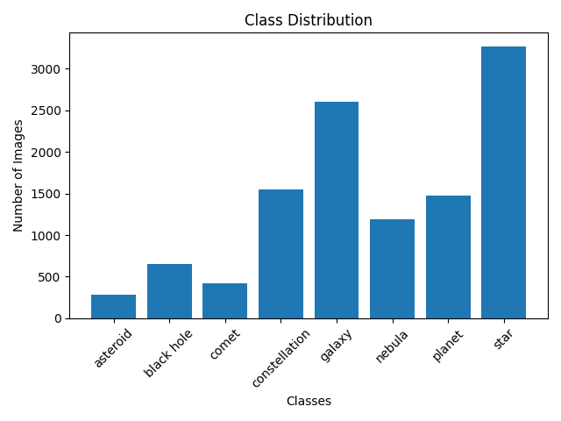
8.1 Appendix A: Dataset Analysis
Figure 1 Dataset Class Distribution Graph

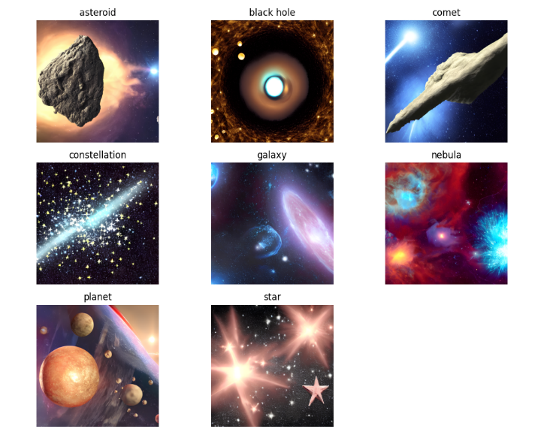
Figure 2 Sample Images from Dataset

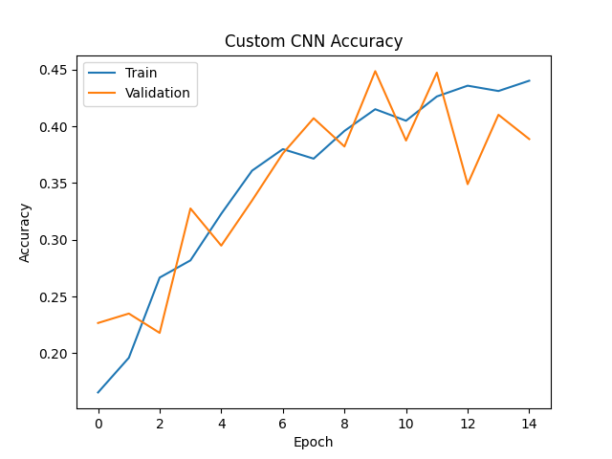
8.2 Appendix B: Custom CNN Results
Figure 3 Custom CNN Accuracy Curve

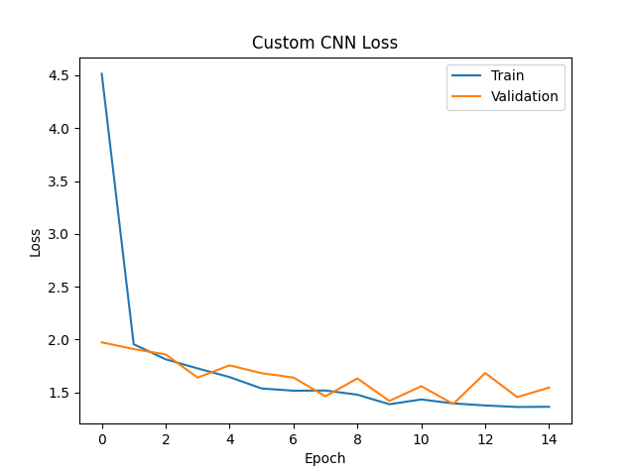
Figure 4 Custom CNN Loss Curve

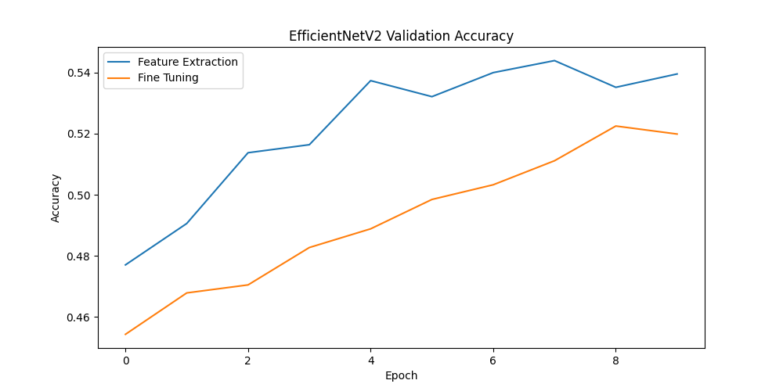
8.3 Appendix C: EfficientNetV2B0 Results
Figure 5 EfficientNetV2B0 Validation Accuracy Graph

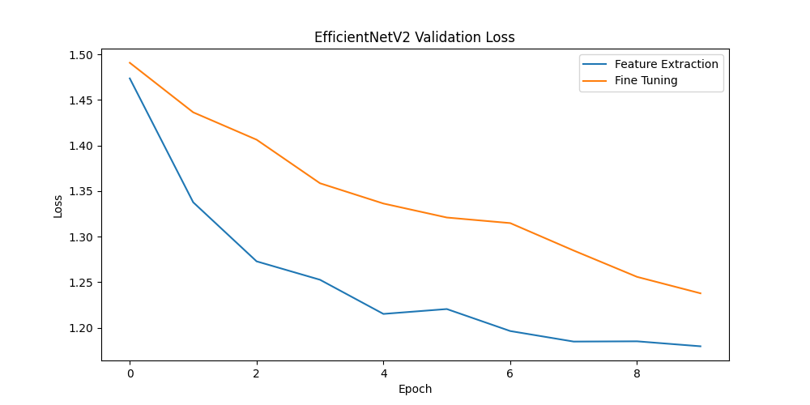
Figure 6 EfficientNetV2B0 Validation Loss Graph

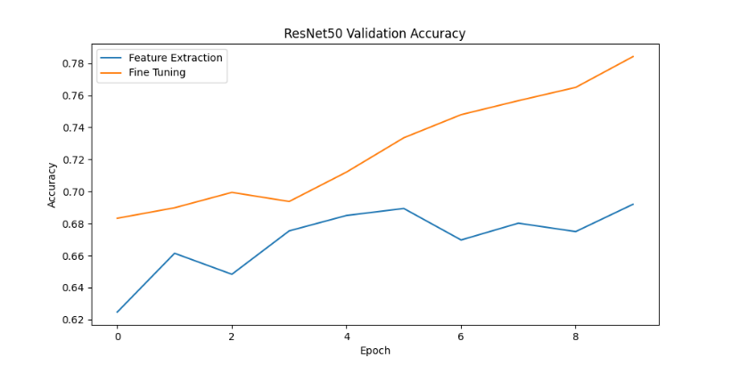
8.4 Appendix D: ResNet50 Results
Figure 7 ResNet50 Validation Accuracy Graph

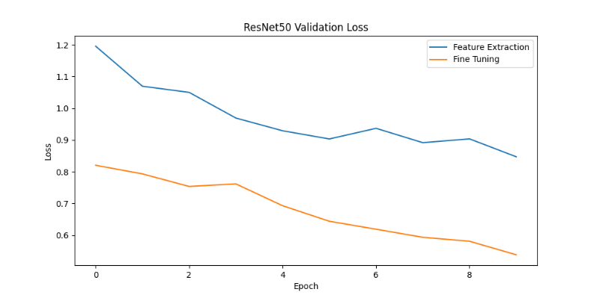
Figure 8 ResNet50 Validation Loss Graph

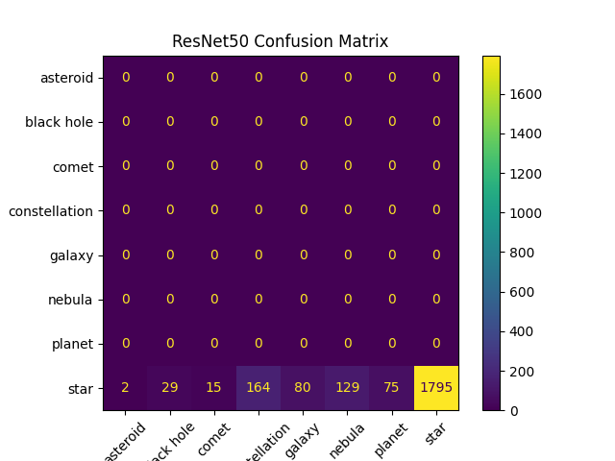
Figure 9 ResNet50 Confusion Matrix

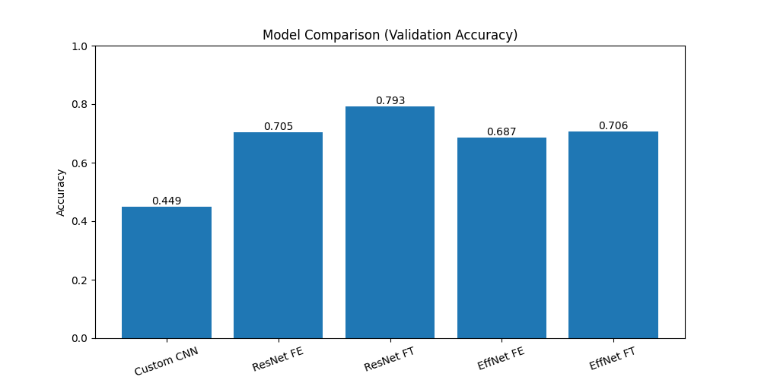
8.5 Appendix E: Model Comparison
Figure 10 Bar chart Model Comparison (Validation Accuracy)

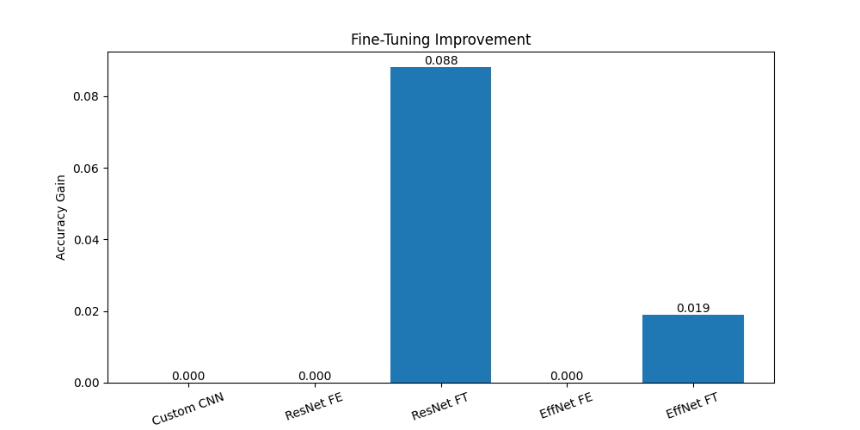
Figure 11 Fine Tuning Improvement Graph

